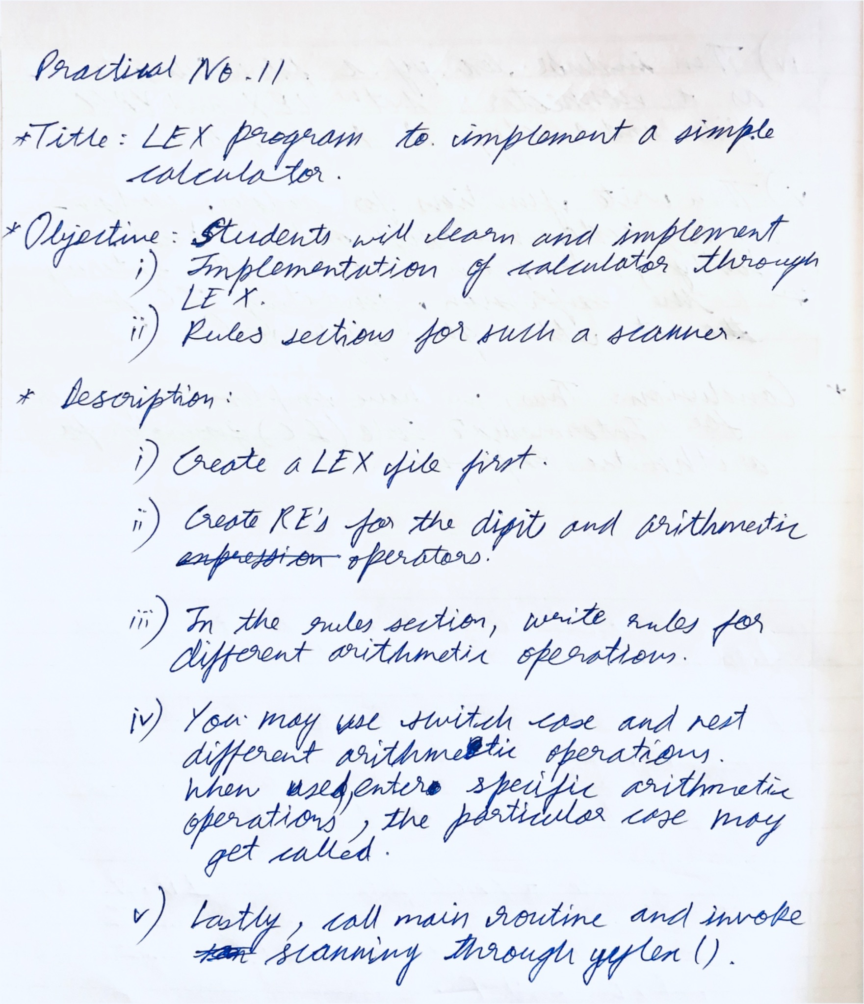

**Code for LEX:**

| DIGIT [0-9]+\.?|[0-9]*\.[0-9]+  %%  [ ] {DIGIT} {yylval=atof(yytext);return NUM;} \n|. {return yytext[0];} |
| --- |

**Code for YACC:**

| %{ #include <stdio.h> #include <stdlib.h> #define YYSTYPE double int yylex(void); void yyerror(char*); %}  %token NUM %left '+' '-' %left '*' '/' %right UMINUS  %%  S:  S E '\n' { printf("Answer: %g\n", $2); printf("Enter expression:\n"); }  | S '\n'  |  ;  E:  E '+' E { $$ = $1 + $3; }  | E '-' E { $$ = $1 - $3; }  | E '*' E { $$ = $1 * $3; }  | E '/' E { $$ = $1 / $3; }  | '(' E ')' { $$ = $2; }  | '-' E %prec UMINUS { $$ = -$2; }  | NUM  ;  %%  #include "lex.yy.c" int main(){  printf("Enter the expression: ");  yyparse(); } void yyerror(char* errorText){  printf("%s\n",errorText); } |
| --- |

**Output:**

